1 Quantum Computing fundamentals.

Quantum computing doesn’t replace classical systems. It amplifies them.

Quantum advantage will not arrive all at once. It will arrive gradually, through hybrid algorithms that work on noisy machines.

Quantum computer uses qubits. Measuring a qubit forces it into a definite state $(0 or 1)$ and irreversibly destroys its quantum state in the process.

1.1 Qubits

A qubit (quantum bit) is the fundamental unit of quantum information. Unlike a classical bit, which is always either $0 or 1$, a qubit can exist in a superposition, a combination of both states simultaneously, until measured.

Physical implementations - a qubit can be any two-state quantum system:
- Photon - horizontal/vertical polarization. Xanadu, PsiQuantum;
- Electron – spin orientation (up/down). Intel;
- Superconducting circuit - two energy levels. IBM Quantum, Google Quantum, Rigetti, SpinQ;
- Trapped ion - two electronic energy levels. IonQ, Quantinuum;
- Nuclear Magnetic Resonance (NMR) - nuclear spins of atoms in liquid molecules at room temp. SpinQ;
- Topological Qubits - Majorana fermions quasiparticles. Microsoft.

There are some concepts behind qubits.

1.2. First is Superposition

A qubit doesn't have to be strictly $0 or 1$. Before measurement, it exists in a superposition of both. Each state has an associated amplitude - a number that determines the probability of that outcome when measured.

$\left|ψ\right\rangle =α\left|0\right\rangle +β|1⟩$, where:

- $α$ and $β$ are complex numbers, called amplitudes;
- $\left|0\right\rangle$ and $|1⟩$ are basis states, as an $0$and$1$ in a classical bit.

Key rule: $|{α|}^{2}+{\left|β\right|}^{2}=1$, which stands for normalized vector’s rule.

Basic states by convention described as follows as a vector, those are also called computational basis:

$\left|0\right\rangle =\left( \begin{matrix}1 \\ 0\end{matrix} \right)$ $\left|1\right\rangle =\left(\begin{matrix}0 \\ 1\end{matrix}\right)$

That means that we can now say that state of the qubit is a vector of 2 numbers (amplitudes):

$$\left|ψ\right\rangle =α\left( \begin{matrix}1 \\ 0\end{matrix} \right)+β\left( \begin{matrix}0 \\ 1\end{matrix} \right)=\left( \begin{matrix}α*1 \\ α*0\end{matrix} \right)+\left( \begin{matrix}β*0 \\ β*1\end{matrix} \right)=\left( \begin{matrix}α \\ 0\end{matrix} \right)+\left( \begin{matrix}0 \\ β\end{matrix} \right)=\left( \begin{matrix}α+0 \\ 0+β\end{matrix} \right)=\left( \begin{matrix}α \\ β\end{matrix} \right)$$

Some examples of qubit states:
Example 1. State of the qubit is equal to 0:

$$α=1, β=0 ⟹\left|ψ\right\rangle =\left(\begin{matrix}1 \\ 0\end{matrix}\right)$$

Probability of measuring 0 is: ${\left|1\right|}^{2}=1→100\%$.
Probability of measuring 1 is: ${\left|0\right|}^{2}=0→0\%$;

Example 2. State of the qubit is equal to 1:

$$α=0, β=1 ⟹\left|ψ\right\rangle =\left(\begin{matrix}0 \\ 1\end{matrix}\right)$$

Probability of measuring 0 is: ${\left|0\right|}^{2}=0→0\%$
Probability of measuring 1 is: ${\left|1\right|}^{2}=1→100\%$.

Example 3. State of the qubit is in ideal superposition:

$$α=\frac{1}{\sqrt{2}}, β=\frac{1}{\sqrt{2}}⟹\left|ψ\right\rangle =\left(\begin{matrix}1/{\sqrt{2}} \\ 1/{\sqrt{2}}\end{matrix}\right)$$

Probability of measuring both 0 and 1 is:
$${\left|\frac{1}{\sqrt{2}}\right|}^{2}=\frac{1}{2}→50\%$$

1.3 Bra-ket/Dirac notation

States described above, such as $|0⟩$ and $\left|1\right\rangle$ are notated with ket (column representation).

For every ket there is associated bra (row representation),which is just turned ket:

$$⟨0|=\left(\begin{matrix}1 & 0\end{matrix}\right) ⟨1|=\left(\begin{matrix}0 & 1\end{matrix}\right)$$

Inner product is computed by taking bra of one and ket of the other:

$$\left\langle 0 | *|1\right\rangle =\left\langle 0 | 1\right\rangle =\left(\begin{matrix}1 & 0\end{matrix}\right)*\left(\begin{matrix}0 \\ 1\end{matrix}\right)=1*0+0*1=0$$

When we multiply qubit state to itself, we will get normalized vector’s rule.

$$\left\langle ψ | ψ\right\rangle =\left(\begin{matrix}α & β\end{matrix}\right)*\left(\begin{matrix}α \\ β\end{matrix}\right)=α*α+β*β=α^{2}+β^{2}=1$$

1.4 Orthogonality

$|0⟩$ and $|1⟩$ forms an orthonormal/computational basis. Their inner product is equal to zero, which means there is no overlap between them. We can describe mathematically any qubit as a linear combination of these two vectors.
Also considering that these vectors are normalized, we can declare that orthogonal+normalized conditions gives us orthonormal basis!

1.5 Measurement (collapse)

Measuring a qubit forces it to "choose", it collapses to either 0 or 1 with probabilities determined by its amplitudes. After measurement, the superposition is gone. This is irreversible.

1.6 State space – the Bloch sphere

The full state of a single qubit can be visualized as a point on the surface of a unit sphere called the Bloch sphere. The north pole is $|0⟩$, the south pole is $|1⟩$, and all points in between represent superpositions.

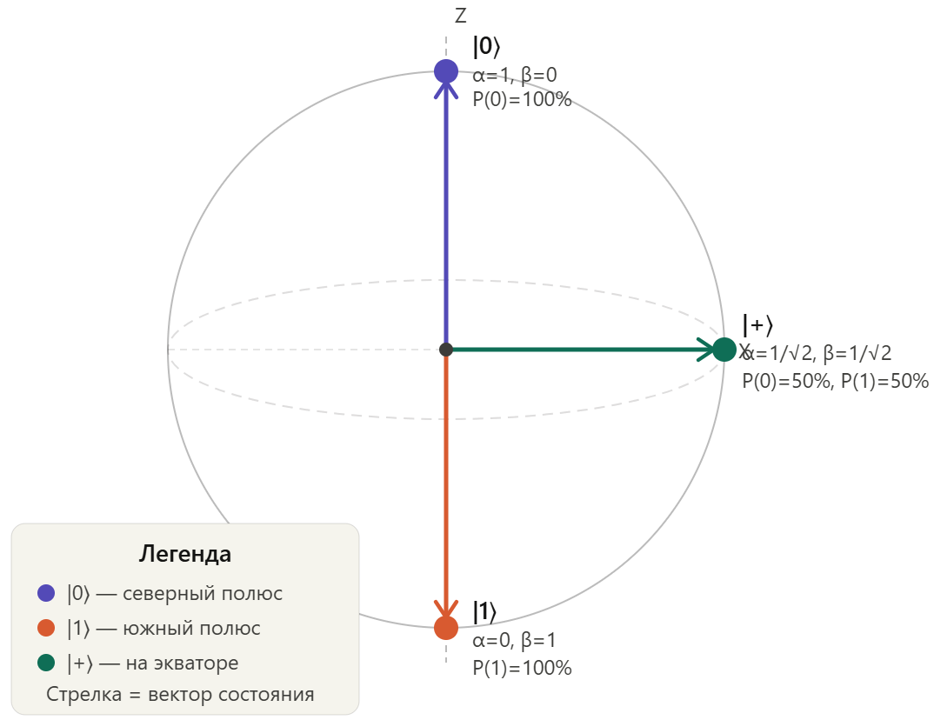
Figure 1. Bloch sphere

1.7 Entanglement

Two or more qubits can become entangled, their states become correlated in a way that has no classical equivalent. Measuring one qubit instantly determines information about the other, regardless of physical distance.

Entanglement is a resource which allows a quantum computer to explore many possibilities simultaneously, performing calculations on multiple inputs at once, not sequentially.

1.8 Decoherence (noise)

Qubits are extremely fragile. Interaction with the environment (heat, vibration, electromagnetic interference) destroys superposition, this is called decoherence.

Qubits must be entangled with each other, but not with the other environment. Even though some materials will be close to our qubits, because we want to measure them.

It is the primary engineering challenge in building quantum computers.

1.9 Wave function and Interference

(1) and the Bloch sphere are just convenient ways to describe the state of qubits.

In reality, state of the qubit is described by quantum wavefunction, which is the fundamental description of everything in quantum mechanics.
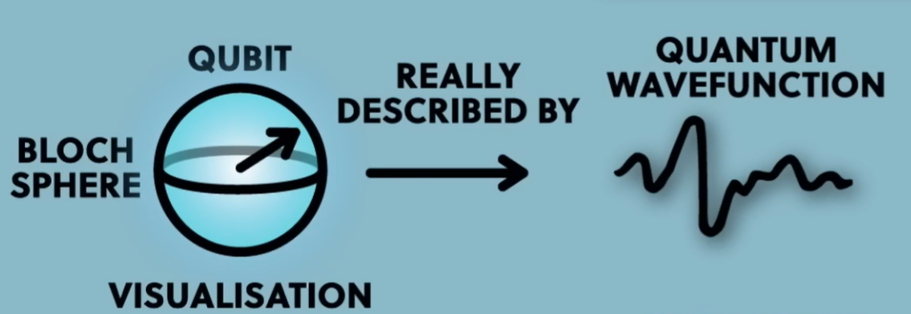
Figure 2. Quantum wavefunction

Combination of all wavefunctions of qubits gives us overall state of our quantum system. Those waves can add together or cancel each other out, just like physical waves in the water.
This called an interference – core mechanism in quantum computing.
There are 2 types of interference:
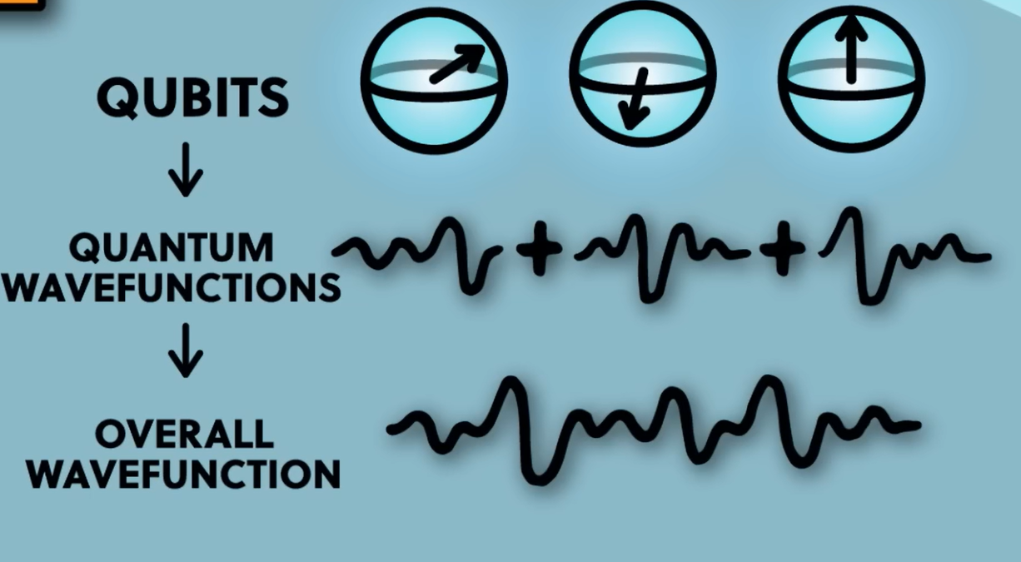
Figure 3. Interference

Constructive interference. When amplitudes add together, the probability of a certain outcome increases.

Destructive interference. When amplitudes cancel each other out, the probability of a certain outcome decreases toward zero.

The goal of quantum computing is:
- to amplify the probability of correct answers → constructive interference
- to suppress the probability of wrong answers → destructive interference

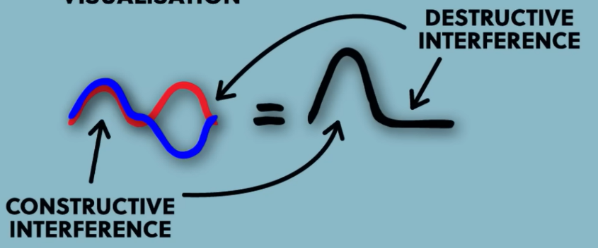
Figure 4. Constructive and destructive interference

1.10 Quantum Error Correction (QEC)

Since qubits are collapsing (breaking the state) when we measure them, we cannot check whether our qubits are working properly or not.

For that reason, we don’t store one qubit information in one physical qubit.

Instead, we store logical information about one qubit in a collective state of several qubits. So, one qubit information spread across several qubits. If some qubits are collapsed by noise or just broken, collective state will be normal.

Syndrome measurement – QEC technique that uses auxiliary/ancilla qubits (those are qubit-helpers that stores information about the errors in physical qubits) to identify errors in logical qubits.

2 Quantum gates

- Basic building blocks of quantum algorithms.
- By applying specific quantum gates to qubits, their states can be transformed, entangled, and etc.
- With those gates, we directly can manipulate state of qubits.
- Can be divided into one-qubit gates, and multi-qubit gates.
- They build entanglement.
- Trivial concept of quantum parallelism. Gates acting on different qubits can run in parallel, but gates on the same qubit must be sequential.

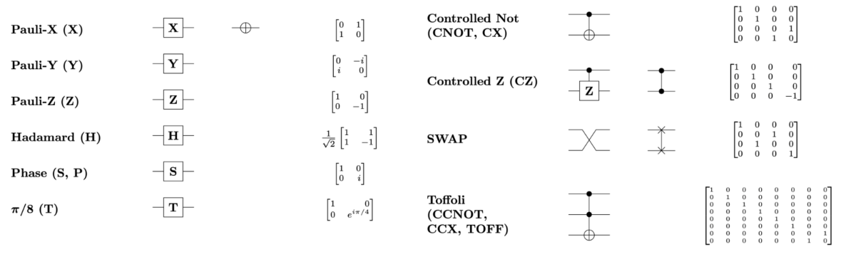
Figure 1. Quantum gates

Quantum circuits are the sequence of quantum gates.

Lifespan of the quantum circuit:
- Initialization of the states of qubits. (often $|0⟩$ or specific initialization methods, such as Gaussian Initalization)
- Gate application, such as Hadamard for superposition, CNOT for entanglement, etc.
- Measurement, producing of classical results.

3 Foundations of Variational Quantum Computing

